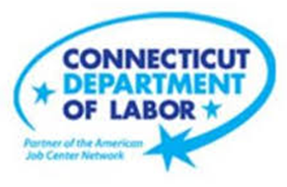

**NEW WEEKLY JOB POSTINGS FROM   
HELP WANTED ONLINE  
Office of Research**

**Week Ending March 5th, 2022: Health Care Drives Total New Ads To Pandemic High**  
WETHERSFIELD, March 5th, 2022 – During the week ending March 5th, 2022, there were 12,709 new postings, up 5,787 new ads from the week ending February 26th. 47 percent of this increase occurred in Healthcare & Social Assistance (+2,742 new ads), with most of that increase occurring at Hartford Healthcare (+1,878 new ads). Occupations with the largest increases were Registered Nurses (1,767 new ads), Tractor-Trailer Truck Drivers (443 new ads), Driver/Sales Workers (361 new ads), and Retail Salespersons (317 new ads). This one-week blip is the fourth time during the last 12 months where total new ads approached or exceeded 10,000. In early July they reached 9,970 and fell to 5,220 by mid-month. In October they persisted near 10,000 for most of the month and in February new ads fell from similar levels to below 7,000 during the second half of the month. The overall gains in Connecticut, up 84% over the week far outpace the U.S. level increase of 31%.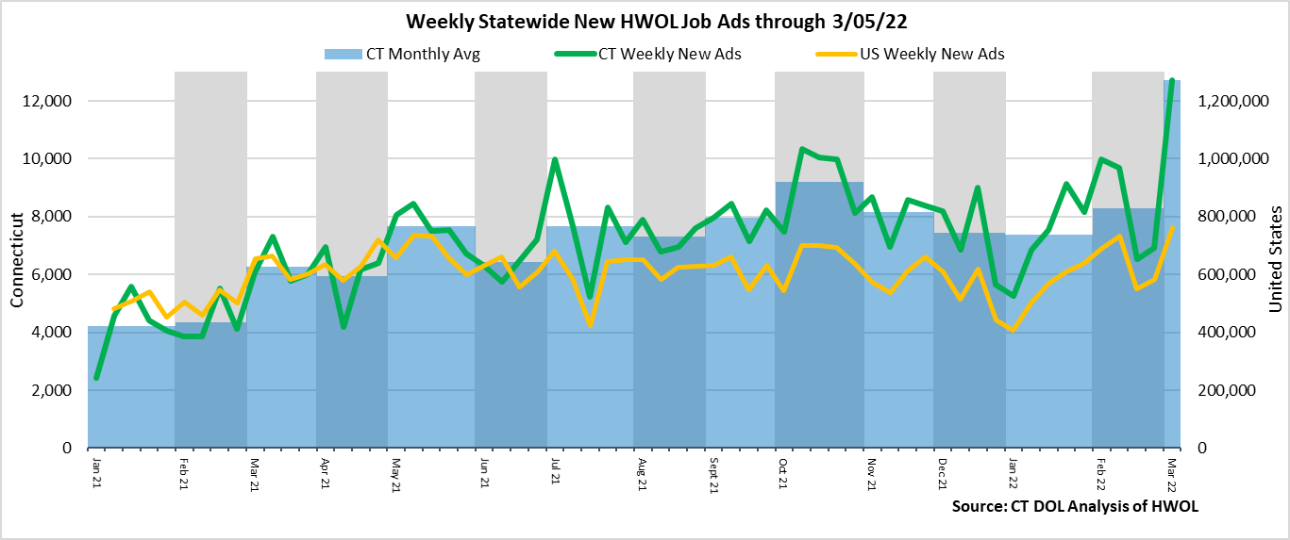

**Industries** with the most new postings include Health Care & Social Assistance, Finance & Insurance, and Pro., Sci. & Tech. Services.

**Occupations** with the most new postings include Registered Nurses, Heavy & Tractor-Trailer Truck Drivers, and Driver/Sales Workers.

**Employers** with the most new postings include Hartford Healthcare, Capital One, and Aya Healthcare.

**The three industries with the most new job postings where:**

* **Health Care & Social Assistance** (3,969 new postings, +223% over the week)
* **Finance & Insurance** (1,023 new postings, +45% over the week)
* **Professional, Scientific, & Technical Services** (630 new postings, +78% over the week)

   
 18 sectors had job posting increases over the week and 3 had decreases. The 18 increasing sectors all saw double-digit percent increases, ranging from +14% in Management to +458% in Utilities. The 84% total increase was heavily influenced by Health Care & Social Assistance, which comprised about 47% of that increase (2,742 out of 5,787 new ads). There is some possibility that this Health Care & Social Assistance level is overstated, but beyond that sector, the 20 others grew by over 3,000 from a week ago. Over four weeks, every sector had new ad increases, ranging from a high of +1,084 in Health Care & Social Assistance, to single digit changes in Management and Mining/Extraction.   
  
 For more information on total job ads by industry for Connecticut and its labor market areas, see the monthly report available here: <https://www1.ctdol.state.ct.us/lmi/hwol.asp>

**New Job Postings by Occupation**



**The occupations with the most new postings were:**

* Registered Nurses (1,767 new postings, +450% over the week)
* Heavy and Tractor-Trailer Truck Drivers (433 new postings, +209% over the week)
* Driver/Sales Workers (361 new postings, +994% over the week)

**Employers with the Most New Job Postings**

Employers with the most new job postings during the week were mostly in Finance & Insurance, Health Care & Social Assistance, and Business Services. The 25 employers shown above account for 29 percent of all new ads. Among the top 25 employers, 22 had over the week ad increases, one was unchanged, and 2 had decreases. Two-thirds of the top 25 increase occurred at Hartford Healthcare, which increased by almost 1,900 new ads over the week. Some of this increase my be overstated, but the large count of Hartford Healthcare job ads was also found during a review of non-HWOL data sources. More than half of the top 25 employers grew by more than double prior week levels. The two decreasing employers fell by less than 25 new ads over the week. Over four weeks, 20 employers in the current top 25 had increases and five decreased, the largest of each being Hartford Healthcare (+1,460 new ads) and Humana (-176 new ads).  
  
**What is HWOL?**The **Conference Board Help Wanted Online**® Data Series (HWOL) measures the number of new, first-time Online job postings and jobs reposted from the previous month for over 16,000 Internet job boards, corporate boards and smaller job sites that serve niche markets and smaller geographic areas. To view more HWOL data, go to: <https://www1.ctdol.state.ct.us/lmi/hwol.asp>